**ECE 385**

Spring 2020

Experiment 1

**Introductory TTL Experiment**

Arkajit Dutta

Section ABD – Tuesday 6 pm

Nicholas Cebry, Wenjie Pan

**Purpose of Circuit**

The first lab was intended to introduce us to TTL logic and how we can build a 2-1 multiplexer using AND, NOR, OR gates. We later had to convert the entire logic in terms of NAND gates as we had to use 7400 gates for the implementation of the lab. This lab also introduced the topic of Static-1 hazards, which arises when the output is 0 temporarily when the logic suggests the output should be one. In this lab, we overcame this problem by combining adjacent SOP terms in the Karnaugh Maps to not allow for a delay when we switch between different SOP terms.

A multiplexer has inputs and select bits which help determine the output from the multiplexer. In this lab, we worked with a 2-1 multiplexer with Inputs – A,B, one select bit – S and output – C. The select bit is used to select the input logic. A multiplexer is extremely relevant in processor architecture and is the primary component in many design aspects.

**Description of Circuit**

In this circuit, we had 2 inputs – A and B, one select bit – S and output – C. The output C is dependent on the select bit. Therefore, if bit S is 1 it will select B and therefore, output C will be 1 when B is 1. When bit S is 0 it will select A and output C will be 1 when A is 1. The functioning of a MUX is described in the figure below.

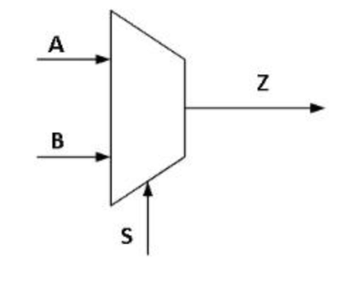

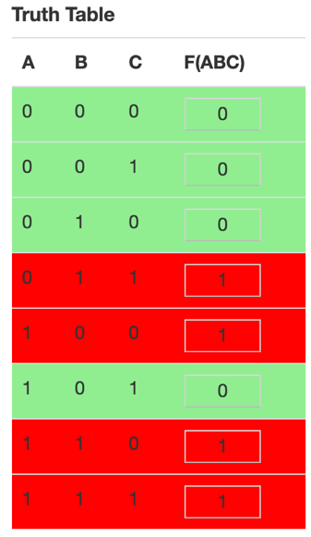*Fig 2.1:2-1 MUX*

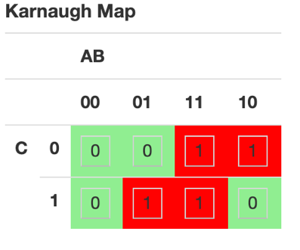

*Fig 2.2: Truth Table and K-map*

Using the K-Map and Truth Table we can deduce the logic of the circuit – **F(ABS) = AS’ + BS.** The logic is implemented below using AND, NOT, and OR gates, as seen in figure 2.4. We had to convert the entire logic into NAND gates as we are using 7400 chips for the lab, therefore the updated logic circuit using only NAND gates is seen in Figure 2.5

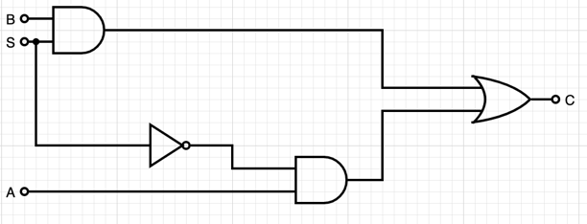

*Fig 2.4: Logic Circuit*

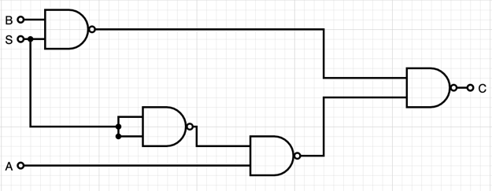

*Fig 2.5: Logic Circuit using NAND gates*

As seen in both the logic diagrams, the process takes a while longer for the AS’ term as there is an extra gate (NOT in Figure 2.4 and an additional NAND gate in Figure 2.5). This leads to a delay in the clock cycle and therefore, momentarily, the output C is not what the logic suggests it should be. This is a Static-1 hazard which is caused by the output C being 0 when it should be 1. The delay in the clock cycle is demonstrated by the timing diagram in Figure 2.6

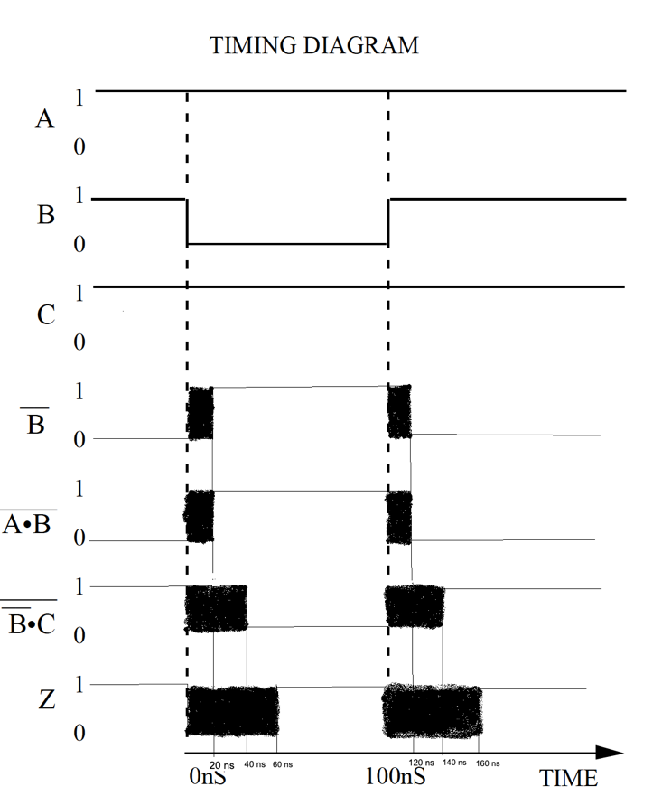

*Fig 2.6: Timing Diagram*

The glitch that occurs is the Static-1 Hazard as the output is delayed by anywhere between 0-60 ns, resulting in inaccurate results momentarily. To overcome this hazard, we combined the adjacent SOP terms on the K-Map so that there is virtually no time spent transitioning from one SOP term to another. This would negate the delay and overcome the static-1 hazard. If we combine the adjacent terms on the K-Map we get a redundant term –AB– which helps remove the glitch.

The new logic for the circuit would therefore be **F(ABS) - AS’ + BS + AB.**

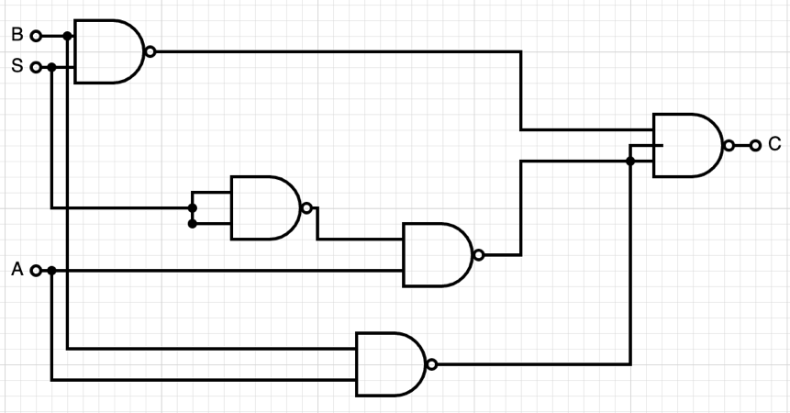

*Fig 2.7: NAND glitch-free circuit*

*Key – Output C (green)*

*Select Bit S (yellow)*

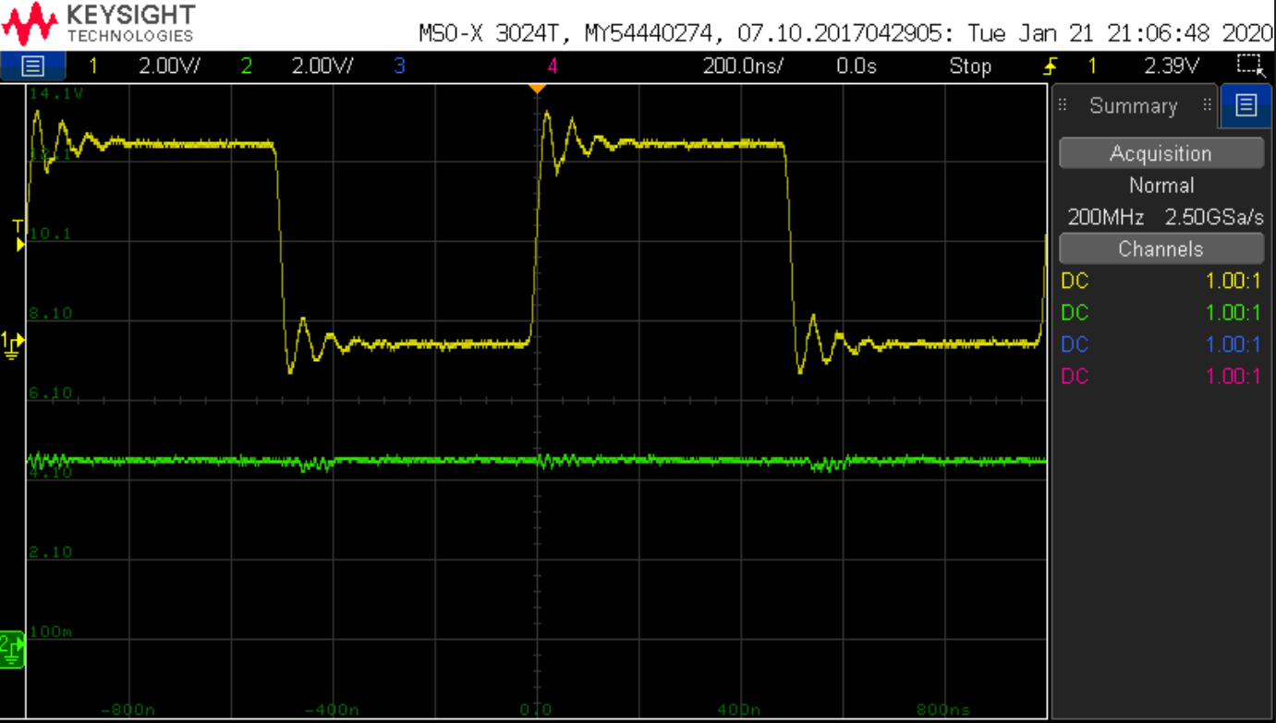

*Fig 2.8 : Oscilloscope trace with no delay*

The inputs B and A were both turned to 1, therefore the output C should also be at 1 at all times, irrespective of the value of Select Bit S, which is reflected in the diagram above. The circuit behaves exactly as it should during its steady state and therefore we have successfully removed the Static-1 Hazard by adding the additional term **AB.**

*Key – Output C (green)*

*Select Bit S (yellow)*

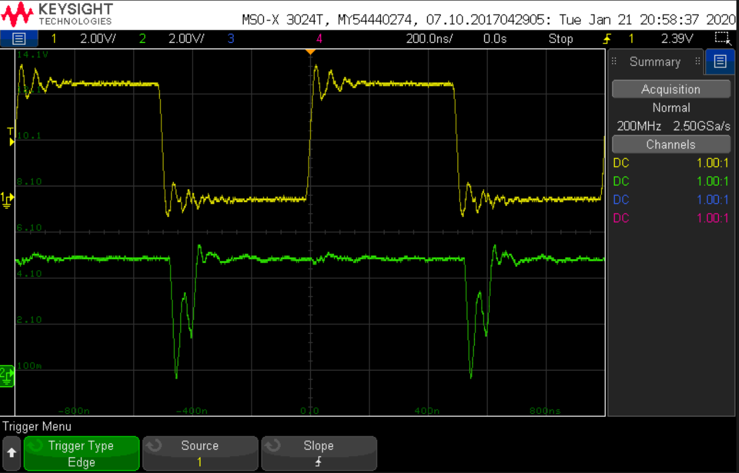

*Fig 2.9: Oscilloscope trace showing a delay*

In this diagram the glitch is visible during the falling edge of S, as the output C falls to 0 momentarily before reaching the steady state of 1. The rising edge of S does not have an effect because the logic is always 1 when S is 1. The glitch is seen again on the second falling edge of S.

**Circuit and Component Layout**

In this circuit, we used 2 7400 chips (2 NAND input) and one 7410 chip (3 NAND input). The first 7400 chip performed the NAND functions a described in the logic above. The second NAND gate was primarily used to invert the Select Bit (S) by passing it through 4 NAND gates. This exemplified the delay in the glitch diagram. The 7410 chip was used because I had 3 inputs to the NAND gate (A’S, B’S’, A’B’) and the resulting output is C.



*Fig 3.1: Component Layout*

Post-Lab Questions: